Dynatrace AI-Driven Development Life Cycle with Kiro powers
Authors: -
Christian Kiesewetter, Principal Product Manager, GTM, Dynatrace
Shashiraj Jeripotula, Principal Partner Solutions Architect, AWS

Introduction
Today, we're excited to announce the integration of Dynatrace with Kiro powers, bringing advanced observability capabilities to Kiro’s AI-powered development assistant. This collaboration enables developers to seamlessly implement Dynatrace's observability best practices through dynamically loaded, specialized contexts within Kiro, without the need for manually configuring JSON files, adding skills or handling instruction files.
In this post, we'll walk through how to install the Dynatrace Kiro power to streamline your AI-assisted development workflow, by providing instant access to advanced observability insights

The Challenge: Observability for Distributed Agentic Systems
Modern cloud applications demand advanced observability solutions, yet achieving efficient implementation poses considerable challenges. Developers frequently encounter difficulties with establishing comprehensive instrumentation across distributed systems, standardizing observability practices organization-wide, maintaining configurations at scale, and integrating observability tools seamlessly into existing development workflows.
These challenges are compounded by restricted access to production environments. Developers typically remain fully dependent on site reliability engineers (SREs) or operations teams to detect and report issues post-deployment and provide the necessary diagnostic information. This segmented workflow results in delayed problem identification and resolution, increased risk of production failures, and reduced efficiency throughout the development lifecycle.

Dynatrace AI-Driven Development Life Cycle with Kiro powers
By connecting Kiro with Dynatrace, developers gain direct access to real-time insights from production environments, receive contextual information down to the root cause of incidents, and get remediation proposals—all within their Kiro IDE.
With the release of the new Dynatrace Kiro power developers get all those insights without the need for manually editing configs or connecting MCP servers. Simply use the power to benefit from
- One-click access to Dynatrace-specific observability patterns and best practices
- Dynamic loading of Dynatrace configurations and hooks
- Specialized context for implementing cloud observability
- Pre-configured monitoring templates aligned with AWS services

How the Integration Works
The powers package all Dynatrace tools, workflows, and best practices into a format that Kiro can activate on-demand, providing
- Smart suggestions for monitoring configuration
- Context-aware observability implementation
- Integration with existing AWS services
Once a developer starts a task, Kiro evaluates installed powers, activates only the relevant ones, and executes the following request flow:
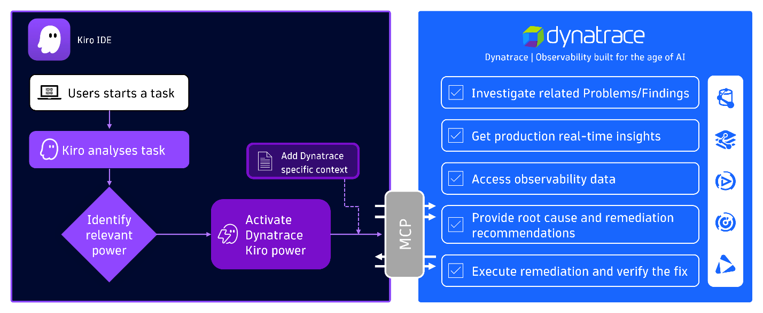
Figure 1 - Schematic request flow of Dynatrace Kiro power execution
Let’s now dig deeper an learn how to activate the Dynatrace Kiro power:

Step-by-step integration guide

Prerequisites
- You’ll need a Dynatrace account. If you don’t already have one, you can start a free 15-day trial.
- Kiro must be installed on your system
- You must have basic familiarity with AWS services and the Dynatrace platform

Prepare integration with Dynatrace
First, you need to create a Dynatrace Platform Token, which is used to define Kiro access, and then add the required permissions for the Dynatrace MCP Server.

Add Dynatrace Kiro power
Dynatrace Kiro power can be accessed by One-click install from Kiro IDE and web, i.e. Browse powers directly in Kiro IDE or in Kiro powers website. In this blog, we will demonstrate One-click install from Kiro IDE.
- Launch Kiro IDE.
- Access the Kiro powers panel by clicking the powers icon in the IDE.
- Select Dynatrace Observability from the Kiro powers Recommended list.
- Click the install button, which installs the needed configurations for connecting to Dynatrace remote mcp server.
- Replace “YOUR_DT_URL” with the following “https://TENANT_ID.apps.dynatrace.com/platform-reserved/mcp-gateway/v0.1/servers/dynatrace-mcp/mcp” and replace TENANT_ID with your Dynatrace environment ID. (You can find your environment ID in the URL of your Dynatrace environment — for example, https://<ENVIRONMENT_id>.apps.dynatrace.com/ui.) Then, replace “YOUR_BEARER_TOKEN” with with the ID of the Dynatrace platform token you created previously (for example, dt0s16.XXXXX).
- Open a new session in the chat and start asking questions to Dynatrace observability platform.

Start building observable applications now
Shifting left on observability has never been this simple. Kiro powers for Dynatrace helps developers speed up their workflow by bringing enterprise-grade observability directly into the IDE—no extra overhead required:
Using Kiro powers for Dynatrace has been a total game changer in the observability space. Deep-dive root cause analysis of complex system issues that once required lengthy manual intervention now happens in seconds, giving us unprecedented speed and confidence.
- Mike Kobush – Sr. Software Performance Engineer, NAIC

Want to see it in action? Watch the video below to learn how to connect Kiro directly to Dynatrace's observability platform, query security vulnerabilities using natural language, run DQL queries, and identify critical issues in production—all without leaving your IDE

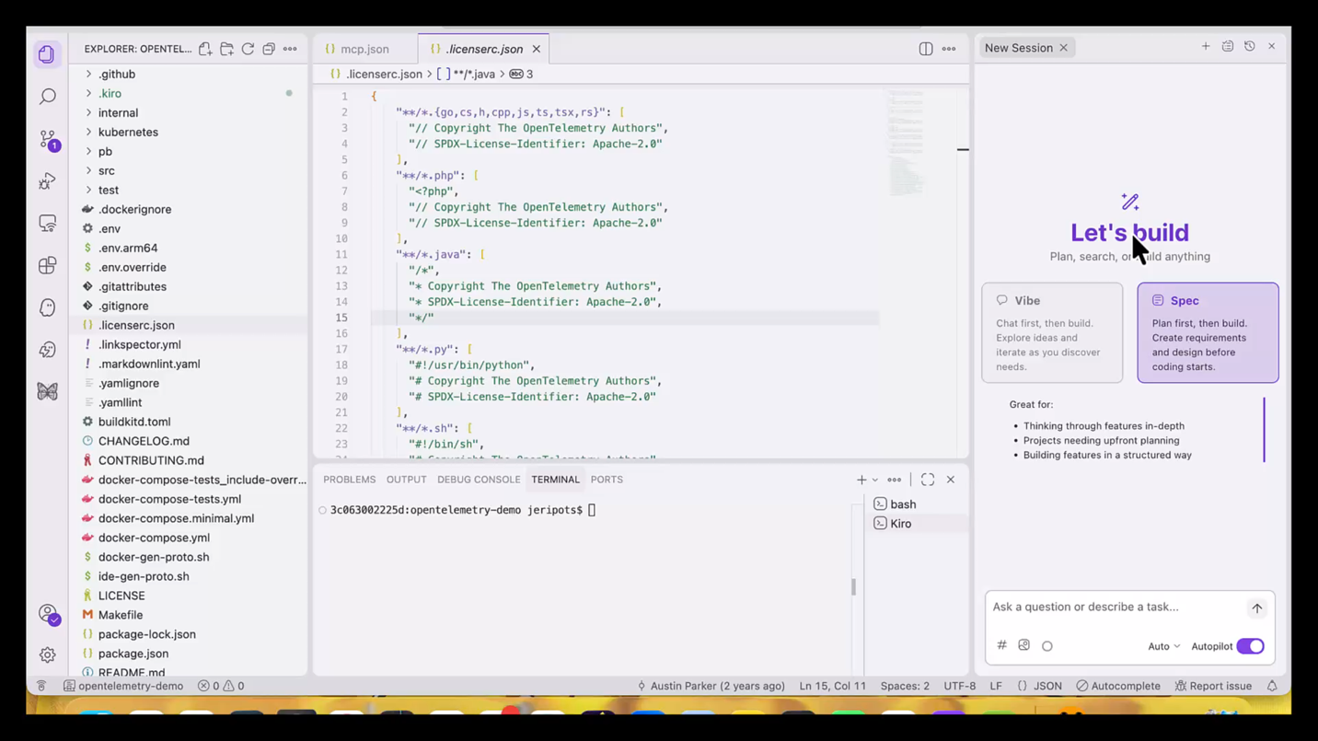
Conclusion
Figure 2 - Kiro powers demo with Dynatrace
Kiro powers have transformed AI-assisted development by making advanced practices accessible to all developers. What once required expertise in configuring AI agents—writing custom steering files, crafting precise prompts, and manually managing tools—now takes just a single click.
The Dynatrace power for Kiro brings this simplicity to observability: real-time production insights, root cause analysis, and performance debugging, all without leaving your IDE.Ready to get started? Observability shouldn't require a context switch. With the Dynatrace power for Kiro, it doesn't. Get started today!

